A dissertation submitted to the University of Greenwich
in partial fulfilment of the requirements for the Degree of

Master of Science
in
Data Science

Player Load Risk Visualizer using Machine Learning
Name: Ganesh Ramakrishnan
Student ID: 001447349
Supervisor: Ala Barzinji
Submission Date: December 2025
Word count:
PLAYER LOAD RISK VISUALIZER USING MACHINE LEARNING
XXXXX
Computing & Mathematical Sciences, University of Greenwich, 30 Park Row, Greenwich, UK.
(Submitted December 2025)
ABSTRACT. Player availability plays a key role in determining success in professional football, yet injuries amongst players remains high despite advances in sports sciences. While elite clubs employ internal monitoring systems, data access restrictions prevent reproducible research and limit the development of widely usable predictive tools. This project proposes the design and implementation of a Player Load Visualizer prototype that integrates machine learning (ML) with simulated injury labels to predict player injury risk. The system will process player match and workload data, generate rolling averages (7-day and 14-day), and compute congestion and positional load metrics. Using these features, supervised learning models (logistic regression, random forest, and gradient boosting) will be trained to estimate injury likelihood. The prototype, deployed as a lightweight web application, will allow practitioners to upload match logs in CSV format and receive risk assessments with accompanying workload visualizations. By addressing the dual challenges of limited public datasets and the translation gap between research and practice, this project aims to contribute both a methodological exploration of ML-based injury prediction and a practical decision-support tool for sport practitioners.

Keywords: Machine Learning; Data Visualization; Logistic Regression; Random forest; Football;

Acknowledgements
I would especially like to thank Professor Ala Barzinji for agreeing to be my supervisor and for his consistent advice, feedback, guidance and support throughout the lifecycle of this MSc Data Science project.
I want to thank both XXXXXXXXXXXXX and XXXXXXXXX for agreeing to have the project demonstration on the schedule day.

Table of Contents

1. Introduction 8
1.1. Background 8
1.2. Aims and Objectives 8
1.3. Methodological Approach 9
1.4. Report Roadmap 9
2. Literature Review / Background Research 11
2.1. Injury Epidemiology in Elite Football 11
2.2. Training Load and the Injury Paradox 11
2.3. Machine Learning Approaches to Injury Prediction 12
2.4. Data Limitations and Simulation 13
2.5. Gaps in the Literature 13
2.6. Relevance to Present Study 14
3. Methodology 15
3.1. Methodological Framework Overview 15
3.2. Data Collection and Sources 15
3.3. Data Preprocessing 16
3.4. Feature Engineering 17
3.5. Injury Simulation Logic 19
3.6. Machine Learning Pipeline Design 21
3.7. Evaluation Metrics 23
3.8. Ethical and Reproducibility Considerations 23
3.9. Summary 24
4. Implementation and System Design 25
4.1. Overview 25
4.2. Development Environment Setup 25
4.3. Data Integration and Transformation Workflow 26
4.4. Data Transformation and EDA 28
5. Machine Learning Model Implementation and Evaluation 32
5.1. Data Partitioning and Cross- Validation: 32
5.2. Preprocessing and Pipeline Construction 33
5.3. Candidate Model Algorithms 34
5.4. Hyperparameter Tuning and Search 35
5.5. Final Model Configuration and Training Outcomes 37
5.6. Feature Importance and Impact 38
5.7. Model Deployment Preparation 41
6. Evaluation and Results 44
6.1. Overview of Evaluation Strategy 44
6.2. Model Performance and Comparative Analysis 45
6.3. Cross-Team Generalisation and Practical Relevance 50
6.4. Interpretability Validation 51
6.5. Evaluation of Web Application Prototype 52
7. Conclusion and Future Work 61
7.1. Evaluation of Web Application Prototype 61
7.2. Key Findings 63
7.3. Limitations 64
7.4. Future Work 65
8. References 66

List of Figures

Figure 1 Data Transformation Flowchart 18
Figure 2 Data Encoding and Preprocessing Pipeline Flowchart 22
Figure 3 Complete Data Processing Flowchart 27
Figure 4 Simulated Injury Mean Percentage 32
Figure 5 Train-Test Data Split 33
Figure 6 Feature Group Creation and Column Transformer Pipeline 34
Figure 7 Random Forrest Confusion Matrix (Test Data) 47
Figure 8 Model Comparison ROC Curve 48
Figure 9 Model Comparison PR Curve 49
Figure 10 Player Injury Risk Dashboard - Upload 52
Figure 11 Streamlit Dashboard - Dataset Preview 53
Figure 12 Streamlit Dashboard - Transformed Data Preview 53
Figure 13 Streamlit Dashboard – Matchday Injury Risk Prediction 54
Figure 14 Streamlit Dashboard - Injury Probability Line Graph for Top 5 Players 54
Figure 15 Streamlit Dashboard - Injury Probability Over Time for Top-Risk Players 55
Figure 16 Streamlit Dashboard - Histogram for Average Injury Risk for Top 10 Players 55
Figure 17 Streamlit Dashboard - Correlation Plot Injury Probability vs Minutes Played 56
Figure 18 Streamlit Dashboard – Summary Insights 57
Figure 19 Streamlit Dashboard - Player Specific Match Results and Injury Prediction 57
Figure 20 Streamlit Dashboard - Player Specific 14 Day Rolling Workload Line Graph 58
Figure 21 Streamlit Dashboard - Player Specific Injury Probability Line Graph 59
Figure 22 Streamlit Dashboard - Player Specific Fixture Count Bar Graph 59

List of Tables

Table 1 Paper Highlighting Model Performance and Usage 13
Table 2 Position Based Load Scoring 28
Table 3 Model Hyperparameter and Optimal Configuration 35
Table 4 Weighted Average Scores of Models on Test Data 36
Table 5 Random Forrest Model Matrix Scoring 38
Table 6 Statsmodel Logit Feature Importance Scores 39
Table 7 Weighted Average Scores of Model Performance on External Data 45
Table 8 Random Forrest Model Performance Scores on External Data 46

- Introduction

  - Background

Injuries hit football clubs hard as one of the toughest ongoing problems. This holds true whether teams play at a pro level or just amateur. It messes with the team's overall performance and player availability. Plus they lead to all sorts of additional headaches down the line. Clubs pour a ton of money into sports science and medical infrastructure these days. Yet, the rate of injuries remains high. As the game moves forward, we are only seeing rising levels of intensity although it maybe at the professional or amateur landscape. The need for a tool/dashboard which any analyst from a team can use to retrieve their perceived outcome is what is required.

The link between training load and injury chances is not always easy to pin down. If the load is too low players might not be ready for the demands. On the flip side too much work or quick jumps in intensity raise the odds of soft tissue problems. Teams have leaned on old school methods like the ACWR(Acute Chronic Workload Ratio) for a while now. But it often spits out results that do not line up well across different game situations. To fix that we switched to a rolling average over seven to fourteen days. It tracks workload patterns in a steadier way. This gives a more dependable approach overall.

Machine learning has come a long way lately in building models for injury risk. It handles tricky mixes of features and those nonlinear ties between things. The catch is that professional level data on this is hard to get. Clubs treat injury and workload info as super sensitive. So, research cannot wrap up fully without it. That creates a real roadblock for testing these tools again or using them beyond top tier setups.

  - Aims and Objectives

The Aim of this project is to be able to develop a Player Load Visualizer prototype that integrates machine learning to predict football player injury risk.
Objectives:
- Conduct a critical literature review of existing injury prediction methods and identify gaps.
- Collect and preprocess football workload data, generating rolling averages, positional load metrics and fixture congestion indicators.
- Simulate injury labels o construct a training dataset suitable for ML classification.
- Train and evaluate ML models (e.g., logistic regression, random forests, gradient boosting, etc.) using appropriate scoring metric (e.g., precision, recall, F1 score, accuracy, etc.)
- Develop a functional prototype (web-based application) allowing CSV uploads and automated injury risk prediction with workload visualization.
- Evaluate the system against success criteria and identify limitations and future improvements.

However, the overall objective of this project is as follows:
“to build and deploy a reproducible, interpretable, and operational machine-learning prototype for injury-risk prediction.”

  - Methodological Approach

The project combines data collection (manual web scraping from football statistics sources), feature engineering (rolling averages, positional scores, congestion factors), and simulation of injury labels. ML models will be trained on this dataset, and the best-performing model will be deployed within a web-based application. The prototype will enable practitioners to upload player data and receive injury risk predictions.

  - Report Roadmap

The roadmap for the project report will be as follows:
- Chapter 2 reviews the literature on injury epidemiology, workload metrics, ML approaches, and simulation strategies.
- Chapter 3 analyses system requirements, constraints, and ethical considerations.
- Chapter 4 presents the design of the data processing, ML pipeline, and prototype.
- Chapter 5 describes the ML model implementation details.
- Chapter 6 presents the evaluation outcomes and results.
- Chapter 7 is the conclusion and the possibility of future work.

- Literature Review / Background Research

  - Injury Epidemiology in Elite Football

Sports injury prediction has improved drastically over the previous decade with the semi-availability of data and the modernisation of computational ability and machine learning techniques, which allows scientists to improve their descriptive statistics and models to correlate to player workloads and injury possibility, sports in the same timeframe has increased in its technicality and intensity. Among that, professional football reports one of the highest injury burdens in team sports, with soft tissue injuries such as hamstring strains accounting for the majority of time-loss injuries (Ekstrand, et al, 2011). These injuries negatively affect team performance and contribute to substantial economic costs for clubs. Injury prevention has therefore become a central focus of sports science research.

  - Training Load and the Injury Paradox

Workload management is widely recognised as a major determinant of injury. (Windt et al, 2017) describe the “training-injury prevention paradox,” where consistently high training loads can improve resilience, while sudden spikes increase risk. The Acute: Chronic Workload Ratio (ACWR) is the most common operationalisation of this relationship. Studies such as (Bowen et al., 2020) link high ACWR spikes with increased injury likelihood in Premier League players, yet systematic reviews highlight statistical flaws and inconsistent predictive value (Michailidis, 2024)(Wang et al., 2019). Rolling averages over 7-14 days have been suggested as a more robust approach to capturing load trends. Also, including contextual factors such as workload perception, fatigue levels and some studies show that including fixture congestion played a significant role in the injury occurrences in professional football.
Including physiological and positional data will also enhance the injury predictions made by models. Sports science literature suggests that injury risks varies based on the position played by the player as each have their own role-specific physical demands on the body. Adding this as engineered features along with fixture congestion scores and BMI play a key role in a model’s performance.

  - Machine Learning Approaches to Injury Prediction

Machine learning has been increasingly applied to sports injury prediction. (Majumdar et al., 2022) provide a comprehensive review of how ML techniques have been used to understand and predict football injuries, highlighting both algorithmic successes and persistent limitations such as small sample sizes and inconsistent injury definitions. (Haller et al., 2023) demonstrated the feasibility of ML models for predicting injury and illness in elite adolescent players. Platforms such as SoccerGuard (Bartels et al., 2024) further illustrate the potential of ML dashboards, though most remain limited to elite contexts and lack external validation. Deep learning approaches (e.g., (Bi et al, 2025)) show high accuracy in synthetic datasets but raise concerns about generalisability. (Leckey et al., 2025a) emphasises challenges such as class imbalance and lack of external validation, pointing to the need for more reproducible approaches.

Multiple ML models have been benchmarked across injury prediction studies, each with unique advantages. Logistic regression remains the simplest and most interpretable baseline but is often limited by its linearity assumptions (Farhadian et al., 2020) Support Vector Machines (SVMs) have shown potential in smaller datasets but struggle with scalability and interpretability in high-dimensional spaces. In contrast, decision methods particularly RF, Gradient Boosting (GB), and XGBoost offer strong performance due to their ability to handle non-linearity and multicollinearity while providing feature importance outputs. RF, in particular, has been repeatedly shown to generalise well in medium-sized datasets (Van Eetvelde et al., 2021).

Paper | Sport | Model | Dataset Size | Performance Metric
(Rossi et al., 2018) | Football | RF | 26 | AUC – 0.78
(Farhadian et al., 2020) | Multi-Sport | RF, LR | 356 | RF Acc – 89.3%  LR Acc – 84.2%
(Briand et al., 2022) | Speed Skating | RF | 40 | Sensitivity - 0.35  Specificity – 0.81
(Van Eetvelde et al., 2021) | Multi -Sport | RF, XGBoost | Varies | AUC – 0.52 – 0.87
(Leckey et al., 2025) | Multi -Sport | RF, XGBoost | 1241 | AUC >0.9
(Bi et al., 2025) | Multi -Sport | CNN, DL | >100000 | Acc – 0.86

Table 1 Paper Highlighting Model Performance and Usage

  - Data Limitations and Simulation

A key constraint in this field is the lack of openly available datasets, as injury and workload data are closely guarded by clubs. This limits reproducibility and generalisation. Simulation offers a pragmatic solution: by generating injury labels based on workload thresholds and congestion patterns, researchers can construct datasets for experimentation. While this reduces epidemiological accuracy, it enables reproducibility and the testing of ML pipelines in academic contexts.

  - Gaps in the Literature

From this review, three major gaps emerge:
- Limited availability of open, reproducible datasets.
- Lack of usable prototypes translating ML findings into practitioner tools.
- Inadequate evaluation methods, with over-reliance on accuracy instead of recall, precision, or ROC-AUC for imbalanced datasets.

  - Relevance to Present Study

This project directly addresses these gaps by:
- Employing rolling averages and positional load scores as predictors.
- Simulating injury labels to create a balanced dataset.
- Delivering a deployable prototype in the form of a CSV-based web app.

- Methodology

  - Methodological Framework Overview

This project adopts a systematic and reproducible methodological strategy towards developing, training, and evaluating a machine learning-based injury prediction model for football players. The overall workflow involves six stages:
- data gathering and preparation,
- preprocessing and cleaning,
- feature engineering,
- injury simulation,
- model training and validation, and
- system deployment via a web-based interactive dashboard.

  - Data Collection and Sources

Data is sourced from FBref (Football Statistics and History | FBref.com, 2018), a publicly available online football statistics database, which was manually extracted in Excel format. Automated scraping was explored, however, security features within FBref prevented repeated API-based access. Instead, formal permission to use the data for academic purposes was obtained via email with representatives at FBref, ensuring compliance with data use policies and also the research ethics guidelines of the University of Greenwich.
The data for the teams Manchester United, Arsenal, Everton, and Aston Villa, were extracted and used for model training and internal testing, which will also cover the match and player data across the 2022-2025 seasons. Similar extraction was done for Liverpool FC as well and they were held out entirely in a separate dataset and will be used for the external validation of the model trained in this project. This allows the research to consider claims of robustness and transferability regarding the model's generalization capability beyond the teams it was trained on.
Transfermarkt was initially considered as a supplementary data source due to its comprehensive injury logs, but was ruled out after preliminary inspection due to inconsistent and incomplete data structures, particularly unstandardized injury reporting, making automated parsing infeasible.
The raw datasets from FBref contained the date of each match, competition type, player position, minutes played, venue, and match outcome. Each of these Excel files was later combined into a single master dataset by using standard column naming and player IDs to unify the data

  - Data Preprocessing

The raw data from FBref needed multiple cleaning and normalisation steps before analysis could be performed. Data preprocessing involved handling missing values, duplicates, and ensuring temporal consistency across multi-season records. The appearance data of each player was organized chronologically by date to enable sequential modeling of player workload over time.
A specific challenge was presented by players who moved from one club to another during the period under survey. To establish continuity, player names and identifiers were kept consistent across club transfers, making them single-player longitudinal records. Missing values for categorical features such as Venue and Start were imputed using contextually appropriate defaults (‘Home/Away Unknown’, or ‘Did Not Start’), while missing numerical attributes were imputed with median values. Identifying duplicate entries, which usually resulted from overlapping fixtures or partial logs of matches, was done based on unique combinations of Player, Date, and Competition, after which they were dropped.
The dataset was split into training and test sets using the 80:20 stratified split, preserving the proportion of injury labels. The combined dataset across these four teams formed the base for developing the model, while the Liverpool dataset acted as a validation dataset for the purpose of external evaluation.

  - Feature Engineering

Feature engineering was an important step in the development of meaningful variables that best described player workload, fitness, and contextual risk factors. Guidance from the sports science literature (Gabbett, 2016; Rossi et al., 2018; Dalen-Lorentsen et al., 2021) was used to develop a variety of derived metrics that could extend the dataset.
For each player’s minutes played, two temporal rolling metrics were calculated: a 7-day rolling average and a 14-day rolling average. These represent proxies for acute and chronic workloads, respectively. The 7-day window captures short-term exertion, while the 14-day window reflects accumulation of sustained load. Both are expressed as moving averages across chronological match appearances (See Figure 1).

The Fixture Count variable represents match congestion and expresses the number of fixtures played over any 5-day period. A congestion flag was then derived, which marked True for any players who had two or more matches within five days. Another variable that was created was the Competition Intensity Index one that assigned a numerical load value to match contexts, such as Premier League = 5, Champions League = 4, Domestic Cups = 3, Friendlies = 1. This was used to simulate the different physical and psychological demands associated with these different competitions.
The Position Load Score reflected positional workload differences for each player's primary position: Goalkeepers = 2, Defenders = 3, Midfielders = 5, and Forwards = 4. This categorical transformation allowed the model to interpret physical demand disparities across playing roles.

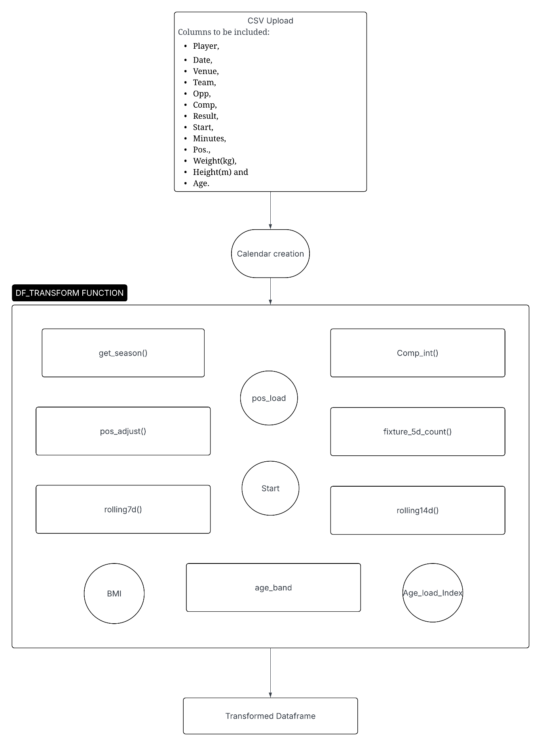
Figure 1 Data Transformation Flowchart
In addition, physiological parameters such as Height, Weight, and Age were measured, the latter two being used to compute Body Mass Index (BMI) and derivative values like BMI_PosLoad, a composite score integrating BMI and positional load, and Age_Load Index. These were developed to reflect stress patterns, assuming that heavier or older players would be at greater cumulative strain for comparable workloads.

Prior to model training, several columns were excluded to prevent redundancy or data leakage. Identifiers such as Player, Team, Opp, Date, and Result were removed to avoid implicit outcome information. Positional or derived metrics with high collinearity were also dropped, including RollingAvg_14d, Age_Load_Index, and PosLoad, as these features exhibited strong correlation (>0.9) with their respective shorter-term or composite counterparts (RollingAvg_7d and BMI_PosLoad). Additionally, raw anthropometric variables (Height(m) and Weight(kg)) were excluded in favour of the derived BMI feature, which provided a more interpretable physiological index. This selective reduction ensured model parsimony and improved interpretability without sacrificing predictive information.

  - Injury Simulation Logic

In the absence of actual injury labels in this FBref dataset, a simulated injury generation process had to be developed. The simulate_injuries() function models realistic player unavailability events through a combination of work-load thresholds and physiological modifiers, targeting an overall injury rate of about 12% in line with epidemiological estimates in elite football.
The process begins by standardising workload metrics using a helper function minmax() to rescale each numerical series between 0 and 1, ensuring comparability across features. Within the main function, player-match records are chronologically ordered, and binary flags identify contextual match conditions such as Did Not Play (DNP), cameo appearances (< 15 minutes), or no start events. Positional loading is mapped to role-specific intensities as explained in the section of Feature Engineering above, and high-intensity competitions are separately marked.
Then four candidate-risk scenarios are generated:
- Acute load spikes - 7-day rolling average above the 90th percentile of minutes played
combined with reduced playing time.
- Chronic accumulation - 14-day rolling average above the 90th percentile of minutes played
- Fixture congestion - at least two matches within 5 days combined with high short term load.
- Streak or contextual fatigue - consecutive matches with minimal rest, especially in high load competitions.

For each candidate record, physiological modifiers are introduced:
- Age Weight (Gaussian centred at 26 years) penalizes extreme ages.
- BMI Penalty reduces risk contribution when BMI deviates significantly from 22.5.
- Age Load Index combines age and positional load to approximate biomechanical stress.

The overall risk score is computed as a weighted sum:
Risk = 0.55 * Rolling_7D + 0.25* Rolling_14D + 0.1 *Age_Weight + 0.05 * BMI + 0.05 * Age_Load_Index

Players with a higher risk score were then sampled sequentially until predefined injury targets were reached. A cooldown time was incorporated as well to avoid repeated player injuries, i.e., to prevent similar players from getting injured again. This ensured the model captured both mechanical and biological risk factors, aligning simulation dynamics with sports science literature (Bahr et al., 2015; Gabbett, 2016).

  - Machine Learning Pipeline Design

Model development followed a modular pipeline structure using scikit-learn. Preprocessing was performed by a ColumnTransformer, with three sub-pipelines for numeric, binary, and categorical features, respectively seen in the flowcart at the end of this section below. Numerical features were imputed at the median and standardized; binary variables were imputed with most-frequent values and categorical features were one-hot encoded.

A stratified KFold cross-validation scheme (k=5) was employed to balance classes across folds. We benchmarked four candidate algorithms: Logistic Regression, Random Forest, Gradient Boosting, and HistGradientBoosting. Hyperparameter tuning is performed via GridSearchCV, optimising for Precision-Recall AUC (PR-AUC), because this metric provides a balanced view of model performance under class imbalance.
Comparative experiments showed that RF exhibited the best trade-off between interpretability, stability, and accuracy. The final Random Forest model utilized 800 estimators, balanced class weights, and unrestricted tree depth. On the overall test set, its performance resulted in a ROC-AUC of 0.72 and a PR-AUC of 0.68.
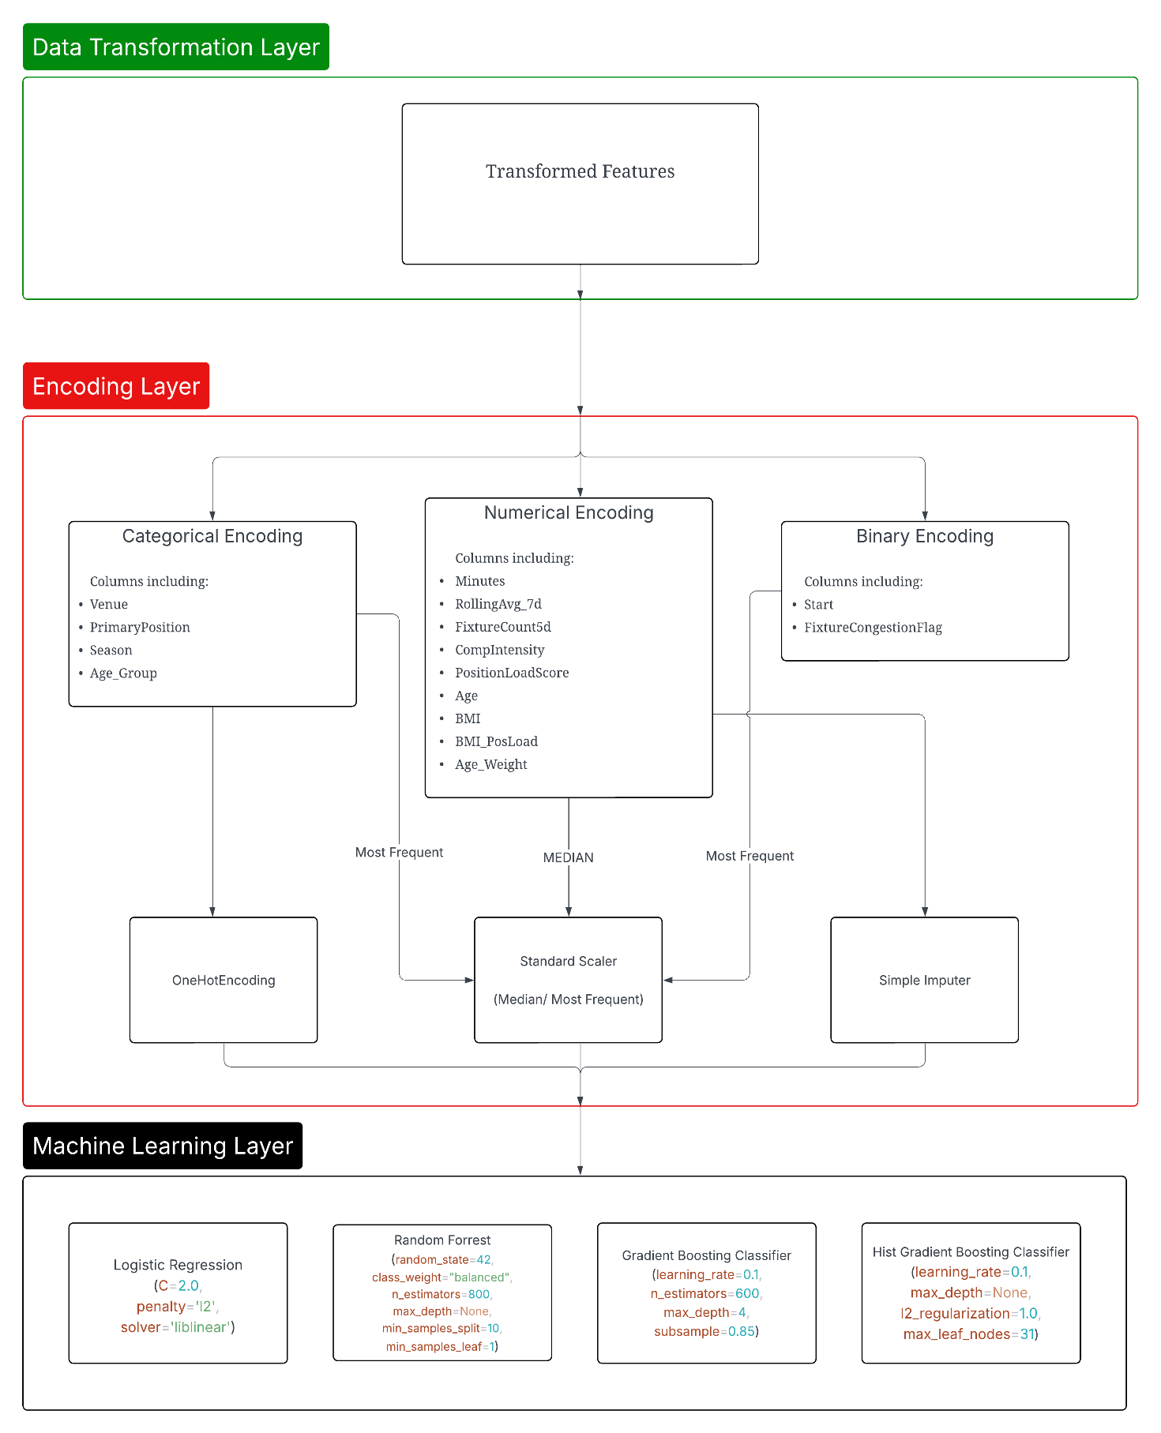
Figure 2 Data Encoding and Preprocessing Pipeline Flowchart

  - Evaluation Metrics

Model performance was assessed using multiple complementary metrics:
- Accuracy: overall proportion of correct predictions.
- Precision: fraction of true positive injury cases among predicted positives.
- Recall (Sensitivity): ability to detect actual injury cases.
- Specificity: capacity to avoid false positives.
- F1-score: harmonic mean of precision and recall.
- ROC-AUC and PR-AUC: robustness indicators for imbalanced datasets.

Injury prediction tasks typically prioritise recall to minimise undetected high-risk players. However, false positives must also be limited to prevent overcautious or inefficient training interventions. Thus, the project’s chosen optimisation metric PR-AUC, balances these considerations.

  - Ethical and Reproducibility Considerations

All analyses followed the research ethical standard, considering transparency, fairness, and privacy. The dataset contains non-sensitive, publicly available match data; hence, it did not include personal medical data. The injury labels were algorithmically simulated and not real, so there would not have been any player confidentiality breach. Permission from FBref makes their structured data tables valid for academic reuse.
Reproducibility was guaranteed by documenting all the preprocessing logic, using the same random seeds at each usage, and coding in a modular fashion. The ultimate trained model and pre-processing pipeline were serialized by joblib to allow reuse directly during web app deployment. The open design principle supports reproducibility by other researchers without any prior dependencies.

  - Summary

The methodology combines data engineering, applied machine learning and ethical data practices to produce a robust, interpretable and deployable system. Through a structured workflow from an ethically sourced FBref data to a feature rich modelled and externally validated, the project demonstrates technical utility and soundness.

- Implementation and System Design

  - Overview

The chapter provides detailed implementation of the Player Load Risk Visualizer system, starting from data preparation to model training and deployment using an interactive dashboard based on Streamlit. The implementation phase translates the conceptual framework established in the methodology into a fully functional prototype by incorporating data preprocessing, machine learning, and web application design.
The implementation process was divided into five main components:
- Development environment configuration
- Data Integration and Transformation Workflow
- Train and persist machine learning models
- Web application development using Streamlit
- Deployment and testing setup

The complete workflow will enable a user to upload raw CSV data, have it preprocessed automatically, generate injury risk predictions, and visualize these risks interactively via the dashboard.

  - Development Environment Setup

The tasks were implemented collectively in python using the Jupyter notebook and Pycharm as IDE’s for this, the libraries used were as follows:
- Pandas – for the data manipulation and processing
- Numpy – for numerical computation
- Scikit-learn – for the machine learning algorithms and pipelines
- Matplotlib – to depict charts highlighting the model’s performance and various things
- Joblib – to help export the model as a pkl file
- Streamlit – to implement the dashboard via which the model’s application is visible, i.e., the web application interface.

The experiments and model training were executed in Jupyter notebook (MSc_Project.ipynb) and the web application interface was developed in pycharm (app.py). The final trained model was exported and a preprocessing functions python script(df_functions.py) was integrated as well.

  - Data Integration and Transformation Workflow

Data which is received form FBref holds basic player level information mostly being – date, competition, team, opponent, minutes played, position played, started the match and some more individual player level data. The model requires only few of the columns mentioned above to ingest and process for the model to perform its predictions on. The user who uploads the csv through the Streamlit interface sees the following sequence being executed:
- CSV Creation: The user is required to upload the csv file with the following columns- Player, Date, Venue, Team, Opp, Comp, Result, Start, Minutes, Pos., Weight(kg), Height(m) and Age.
- Data Transformation – The code then validates to check if the uploaded csv contains all the required columns for the preprocessing pipeline function (df_function.py) to be able to extract the required data for the model to work on. The function holds other mini functions that helps extract BMI, rolling average and so on, it will be expanded and elaborately explained in a section later below.
- Encoding and Standardization: The data is also then encoded based on it as categorical, numerical and binary columns of the dataframe to be compatible with the model’s feature expectations.
- Output: The output dataframe from the function holds the model ready dataset that meets all the feature expectations.
The following flowchart highlights the above process in a much clearer visual process of the dataset modification pipeline

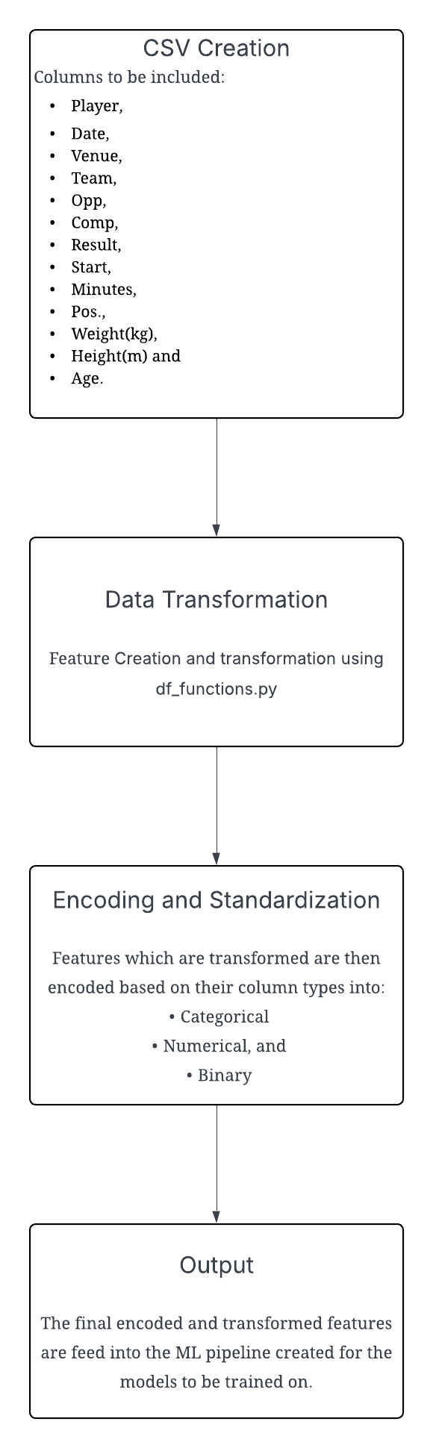
Figure 3 Complete Data Processing Flowchart

  - Data Transformation and EDA

This section will expand on the data transformation function – (df_functions.py), it holds the following functions that will be used to transform the uploaded csv file:
- get_season() – This function helps create a categorical column to help differentiate which season the game is being played in, by using the month of ‘August’ as the default differentiating point. Since the dataset is between the timeframe of 2022 – 2025 it returns the values as 2022/23, 2023/24 and 2024/25.
def get_season(date):
year = date.year
if date.month >= 8:
return f"{year}/{str(year+1)[-2:]}"
else:
return f"{year-1}/{str(year)[-2:]}"
- pos_load() – This dictionary field helps to convert a theoretical column into a column that has an impact on the overall injury prediction a model will make for a player. So, the weights were assigned –
Position Played | Numerical Weightage
Goalkeeper (GK) | 2
Defender (DF) | 3
Forward (FW) | 4
Midfielder (MF) | 5

Table 2 Position Based Load Scoring
- comp_int() – This function compares a list of high intensity competitions that have a major impact on the team and adds a weight to it to signify its importance. Competitions like the ‘Premier League’ and ‘Champions League’ have been given a weightage of 5, whereas other competitions like ‘FA Cup’ and ‘EFL Cup’ has been given a weight of 4 and lower.
hi_comp = {"Premier League","Champions League","Europa League"}
def comp_int(x):
if x in hi_comp:
return 5
elif x == "FA Cup":
return 4
elif x == "EFL Cup" or x == "FA Community Shield":
return 3
else:
return 1

- pos_adjust() – This function helps convert cases where some players may have played more than one role in a game, so it simplifies the positions field so the positional weightage can be applied easily.
def pos_adjust(x):
if x == "FW,MF":
return "FW"
elif x == "MF,FW":
return "MF"
elif x == "MF,DF":
return "MF"
elif x == "DF,MF":
return "DF"
elif x == "DF,FW":
return "DF"
elif x == "FW,DF":
return "FW"
else:
return x

- Rolling7d and Rolling14d – This function was created to calculate the rolling window calculation of minutes played by a player in 7 days and 14 days by adding up the minutes played, this will play an important role in the simulating the injury entries, which will be explained in a chapter later down the line.
def rolling7d(df):
df = df.copy()
rolling_vals = []
for player, grp in df.groupby("Player"):
grp = grp.set_index("Date").sort_index()
roll7 = grp["Minutes"].rolling("7D").sum().values
rolling_vals.extend(roll7)
df["RollingAvg_7d"] = rolling_vals
return df
- Fixture_5d_count() – This function was created to count the number of matches the given player is playing in a 5 day timeframe by using the minutes column as the primary reference point.
def fixture_5d_count(df):
df = df.copy()
rolling_counts = []
for player, grp in df.groupby("Player"):
grp = grp.set_index("Date").sort_index()
count5 = grp["Minutes"].gt(0).rolling("5D").sum().values
rolling_counts.extend(count5)
df["FixtureCount5d"] = rolling_counts
return df

- Age_band() – This function helps create a categorical column for various age ranges the players are in.
def age_band(age):
if age <= 21:
return "developing"
elif age > 21 and age <=28:
return "peak"
elif age > 28 and age <=32:
return "mature"
else:
return "decline"

- df_transform() – this function is responsible for collectively write the details obtained from the other functions above and then implement its own changes. First, the games played by the players are converted into a calendar format by taking the range of dates (per player) of the games played and then creating a dataframe of those dates. Secondly, its applied on all the players in the range and the other functions results are obtained, additionally, column entries like BMI, BMI_PosLoad (a column to calculate the positional impact based on a player’s overall BMI) and the Start column which is converted into a binary column. The code for the entire function is available later in the Appendix below.

- Machine Learning Model Implementation and Evaluation

Following the feature engineering, the model is set to be trained with the dataset (no. of rows = 13339 records) formed of data from the teams – Manchester United, Arsenal, Everton and Aston Villa. The simulated injury column holds binary values (1/ 0) and based on the simulation explanation from the previous section, the column holds 12.994% positive cases, which is in range with the injury frequency found in elite football as per (Van Eetvelde et al., 2021) as seen in the figure below:

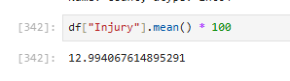
Figure 4 Simulated Injury Mean Percentage

With this, the following workflow contains the following stages:
- Data splitting and class balanced sampling:
- Pipeline creation for preprocessing and model training
- Hyperparameter optimisation using Gridsearch, and
- Model comparison and final model deployment.

  - Data Partitioning and Cross- Validation:

The dataset has been partitioned in a 80:20 stratified train- test split, preserving the ratio of injury and non-injury cases. The need for stratifying data is necessary due to the limited availability of simulated injury data in the dataset and sets an equal precedent for subsets that contains both positive and negative samples. The use of a separate ‘Liverpool FC’ dataset for just validation purposes was created as well.

Within the training data, model tuning was performed using 5-fold stratified K-Fold cross validation which helps maintain class balance across all the folds. The ROC-AUC (Receiver Operating Characteristic – Area Under Curve) is used as the preferred optimisation metric for this process due to its ability to handle class imbalance.

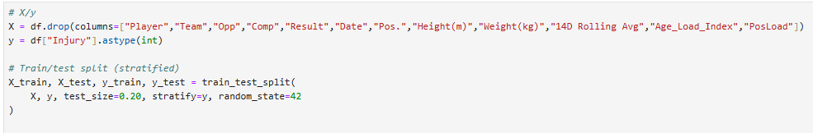
Figure 5 Train-Test Data Split

  - Preprocessing and Pipeline Construction

To eliminate the risk of data leakage, all preprocessing of data was performed within an unified Pipeline (available in the scikit- learn module). The design made sure that identical transformations were applied throughout the training phase of the process. The following pipelines were created:
- Numeric features: The numeric columns, had a SimpleImputer() applied to get the median value of the records an after that the StandardScaler() was applied too.
- Categorical features: The categorical values were One-hot encoded to help add features to the dataset as well as SimpleImputer() to get the most frequent values.
- Binary features: These columns, had a SimpleImputer() applied to get the most frequent values.

The column transformer function was used to combine all the sub-pipelines, into a single pipeline, allowing data to be processed in a sequential format. This helped to simplify the integration into the models that will be used later on.
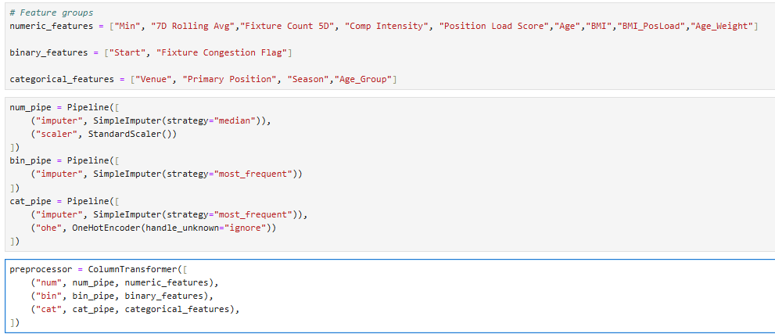
Figure 6 Feature Group Creation and Column Transformer Pipeline

  - Candidate Model Algorithms

There are four model algorithms that were tested to identify the best model for injury predictions:
- Logistic Regression – a linear baseline option which has high interpretability and limited flexibility.
- Random Forrest – A random forest is a meta estimator that fits a number of decision tree classifiers on various sub-samples of the dataset and uses averaging to improve the predictive accuracy and control over-fitting.
- Gradient Boosting - This algorithm builds an additive model in a forward stage-wise fashion; it allows for the optimization of arbitrary differentiable loss functions.
- HistGradient Boosting - This estimator is much faster than Gradient Boosting for big datasets (n_samples >= 10 000). This estimator has native support for missing values (NaNs). During training, the tree grower learns at each split point whether samples with missing values should go to the left or right child, based on the potential gain.

For a fair comparison, each of the models were trained with the same preprocessing pipelines and cross-validation folds.

  - Hyperparameter Tuning and Search

By utilizing GridsearchCV, first test runs of choosing which model will best suit the project’s requirements was performed. The idea is to be able to get a model that maximizes on the ROC-AUC score over five folds and the table below highlights the tuning summary from tests performed:

Model | Hyperparameters | Optimal Configuration
Logistic Regression | model__C: [0.1, 0.5, 1.0, 2.0, 5.0],  model__penalty: ["l2"],  model__solver: ["lbfgs", "liblinear"] | model__C: 2.0,  model__penalty: l2, model__solver: liblinear
Random Forrest | model__n_estimators: [200, 400, 800],  model__max_depth: [None, 10, 20, 40],  model__min_samples_split: [2, 5, 10],  model__min_samples_leaf: [1, 2, 4] | model__max_depth: None, model__min_samples_leaf: 1, model__min_samples_split: 10, model__n_estimators: 800
Gradient Boosting | model__n_estimators: [200, 400, 600],  model__learning_rate: [0.01, 0.05, 0.1],  model__max_depth: [2, 3, 4],  model__subsample: [0.7, 0.85, 1.0] | model__learning_rate: 0.1, model__max_depth: 4, model__n_estimators: 600, model__subsample: 0.85
HistGradient Boosting | model__max_depth: [None, 6, 20],  model__learning_rate: [0.03, 0.05, 0.1],  model__max_leaf_nodes: [31, 63, 127],  model__l2_regularization: [0.0, 0.1, 1.0] | model__l2_regularization: 1.0, model__learning_rate: 0.1, model__max_depth: None, model__max_leaf_nodes: 31

Table 3 Model Hyperparameter and Optimal Configuration

The above parameters were used to train and fit the data with the model under the ‘ROC-AUC’ method of scoring to better test and understand the model’s performances during the training period and the following table highlights the scoring retrieved after the tuning was performed.

 | Weighted Average Scores
Model | ROC-AUC Score | Recall | Precision | F1-score | Accuracy
Logistic Regression | 0.874 | 0.756 | 0.886 | 0.794 | 0.756
Random Forest | 0.924 | 0.874 | 0.899 | 0.883 | 0.874
Gradient Boosting | 0.941 | 0.915 | 0.908 | 0.909 | 0.915
HistGradient Boosting | 0.931 | 0.908 | 0.899 | 0.896 | 0.908

Table 4 Weighted Average Scores of Models on Test Data

The results showcase that the gradient boosting models seem to be handling the training data well and retrieve better weighted average scores than the other models in test, ‘weighted average scores’ in general highlight how the models perform overall on both the injury and non-injury classes, and demonstrates effectively how it performs on a balanced use case. But, in this case the dataset is imbalanced with only 13% of the data is simulated to be injured, so the accurate prediction of successful injured use case is very important, i.e., the score shown on the class-specific Injury case is what is to be focused on. The further explanation of this will be done in the Results and Evaluation chapter but the outcome of this find is that the Random Forest (RF) model achieves the one of the best recall scores (0.728) amongst the models and is chosen to make future predictions with. Logistic regression model had a higher recall score (0.843) but its overall performance in comparison was poor when compared with the random forest model.

  - Final Model Configuration and Training Outcomes

The random forest model chosen was then retrained on the optimal configuration as seen in the code block below:
RandomForestClassifier(
random_state=42,
class_weight="balanced",
n_estimators=800,
max_depth=None,
min_samples_split=10,
min_samples_leaf=1
)

A random state was chosen and added so that if in case the model was to rerun, it returned the same stats as previously experienced while testing it for the first time. The model returned an optimal result as depicted in the results metrics below alongside the confusion matrix figure, highlighting the successful predictions of the injured and non-injured cases when compared with the original table.

 | Precision | Recall | F1-score | Support | Accuracy
0 | 0.957 | 0.896 | 0.925 | 2435 | 0.874
1 | 0.512 | 0.728 | 0.601 | 364
Macro-avg | 0.734 | 0.812 | 0.763 | 2799
Weighted-avg | 0.899 | 0.874 | 0.883 | 2799

Table 5 Random Forrest Model Matrix Scoring
As you can see in the above matrix, showcases the high recall score of the model which is what we are after in this use case.

  - Feature Importance and Impact

In this section, we will discuss which features play an important role in the model’s performance and also dive into the utilization of statsmodel (statsmodels 0.14.4, 2024; Avi Chawla, 2024)module to achieve the required numeric info.

To better understand the directionality and significance of the features used by the Random Forest, a logistic regression was fitted on the same pre-processed dataset. The following table presents the results of this auxiliary analysis, showing the estimated coefficients (coef), standard errors (std err) and p-values (P>|z|) for each predictor. The model used 11,192 training observations and achieved a pseudo-R² of 0.386, indicating moderate explanatory power within a binary classification context.

Features | coef | P>|z| | std err
Minutes | -0.0581 | 0.605 | 0.112
RollingAvg_7d | 1.2761 | 0 | 0.061
FixtureCount5d | 1.4336 | 0 | 0.325
CompIntensity | -0.099 | 0.262 | 0.088
PositionLoadScore | -1.9192 | 0.001 | 0.566
Age | -0.1074 | 0.23 | 0.09
BMI | -0.4895 | 0.001 | 0.145
BMI_PosLoad | 1.9584 | 0.001 | 0.569
Age_Weight | 0.0314 | 0.697 | 0.081
Start | 0.864 | 0 | 0.195
FixtureCongestionFlag | -2.0284 | 0 | 0.429

Table 6 Statsmodel Logit Feature Importance Scores
Each coefficient reflects how a one unit increase in that feature affects the log-odds of an injury occurring (Injury = 1), assuming all other variables are held constant.
- Positive coefficients indicate that increases in the feature correspond to higher injury risk, while
- Negative coefficients suggest a protective or inverse relationship with injury likelihood.
The p-values show whether these relationships are statistically significant at the 95% confidence level (p < 0.05).

The coefficients indicate several statistically significant predictors (p < 0.05), supporting the Random Forest’s feature-importance trends.
- RollingAvg_7d (β = 1.27, p < 0.001) - The 7-day rolling average of minutes played exhibits a strong and significant positive association with injury likelihood. This confirms that acute workload spikes substantially elevate the risk of soft-tissue or fatigue-related injuries.
- FixtureCount5d (β = 1.43, p < 0.001) - A higher number of fixtures in a five-day window also increases injury risk, aligning with sports medicine literature linking fixture congestion and recovery limitations to increased strain.
- BMI_PosLoad (β = 1.95, p < 0.001) - The combined BMI and positional load index is another significant positive factor, implying that heavier players performing in high-load roles face elevated biomechanical stress.
- PositionLoadScore (β = –1.91, p = 0.001) - This negative coefficient may reflect role adaptation, suggesting that players in high-load positions (e.g., midfielders) adapt physiologically over the season, reducing relative injury probability.
- BMI (β = –0.49, p = 0.001) - A moderate negative effect, possibly indicating that higher body mass (when proportionate) correlates with improved robustness and tolerance to physical load.
- FixtureCongestionFlag (β = –2.02, p < 0.001) - Although counterintuitive, this negative sign likely reflects rotation effects players exposed to congestion are often managed more conservatively, or rested, which lowers immediate injury risk.

Other variables, including Minutes, Age, Start, and Competition Intensity, were not statistically significant in isolation (p > 0.05), though their interaction effects are likely captured by the Random Forest’s non-linear structure.
The categorical dummy variables (Venue, Position, Season, Age_Group) have been one-hot encoded; coefficients for these were not statistically stable due to sparse representation across categories and multicollinearity with interaction terms, hence the “NaN” values were reported for some levels.

The statistically significant positive coefficients, particularly RollingAvg_7d, FixtureCount5d, and BMI_PosLoad, align strongly with the Random Forest’s top-ranked feature importances. This demonstrates that the features driving the Random Forest’s injury-risk predictions also exhibit consistent, interpretable linear relationships with injury probability. The logistic regression thus serves as an interpretability cross-check, confirming that the engineered workload and physiological metrics are not only predictive in a non-parametric model but are also statistically meaningful under a traditional inferential framework.

Together, these results substantiate the Random Forest’s predictive validity and provide a physiologically grounded explanation of the key workload factors contributing to simulated injury risk.
  - Model Deployment Preparation

After the Random Forest was identified as the final and most effective classifier, the next stage involved preparing it for reproducible use and integrating it into an operational web application. The goal was to ensure that the trained model, along with its preprocessing logic, could be reused in exactly the same form during inference, preserving both accuracy and consistency.

During training, the Random Forest was encapsulated inside a scikit-learn pipeline that included every transformation applied to the data: numerical scaling, categorical encoding, and binary conversions implemented through a ColumnTransformer.
Combining preprocessing and model inference inside a single pipeline object eliminated the possibility of mismatch between the transformations used in training and those applied later to new data.
This design guaranteed that any future dataset passed to the model would undergo identical preprocessing, feature ordering, and scaling before prediction.
Once the final model configuration was established, the entire pipeline was serialised using the joblib library. This process produced a binary file, final_rf_model.pkl, containing the fitted transformer, encoder parameters, and the Random Forest’s tree structure.
The model could then be reloaded and used immediately for inference without retraining, as illustrated below:
import joblib
joblib.dump(final_rf, "final_rf_model.pkl")

Serialisation freezes the model and its parameters, ensuring that identical inputs will always yield identical predictions. Each exported version was stored with metadata such as the training set version and corresponding performance metrics, creating a transparent and traceable audit trail consistent with reproducibility best practices in applied machine learning.

For deployment, a lightweight and interactive environment was required. The Streamlit framework was chosen because it allows direct execution of Python code within an intuitive browser-based interface. Unlike web frameworks such as Flask or Django, Streamlit requires no separate front-end code; instead, visual elements are bound directly to Python logic, making it ideal for a research prototype that must demonstrate function rather than full enterprise integration. This approach allows rapid iteration and ensures that future model updates can be incorporated simply by replacing the persisted ‘.pkl’ file.

The deployed application (web_app.py) acts as a Player Load Risk Visualizer. Users begin by uploading a .csv file containing player-match workload data. Once uploaded, the file is processed automatically through the same transformation sequence used during training by invoking df_transform_v4(). This includes handling of missing values, categorical encoding, and numerical scaling. The resulting feature matrix is passed to the persisted model, which generates both binary classifications (0 = no risk, 1 = injury risk) and probability estimates between 0 and 1. The probability values allow users to interpret injury likelihood as a spectrum rather than a strict threshold.

Predictions are then visualised interactively through Streamlit widgets and Matplotlib charts. The interface highlights players with elevated injury risk, displays the distribution of predicted probabilities across the team, and plots rolling workload curves for individual athletes. Users can filter results by player, position, or competition to explore specific workload patterns, because all preprocessing and inference steps occur within the serialised pipeline, the system guarantees that predictions produced through the dashboard are numerically identical to those obtained in the notebook environment.

From an architectural standpoint, the application consists of two logical layers.
The model layer houses the persisted Random Forest pipeline, ensuring data integrity and consistent inference. The presentation layer, built entirely in Streamlit, manages user interaction, calls the model layer for prediction, and renders visual outputs. This modular structure supports straightforward maintenance; newer models trained on updated seasons or datasets can replace the existing .pkl file without altering the interface or preprocessing logic.

To maintain reproducibility, all library versions used during training (scikit-learn 1.3, pandas 2.1, NumPy 1.26) are imported explicitly in the deployment environment. Random seeds (random_state = 42) are fixed to guarantee deterministic results. User-uploaded files are processed in memory only and discarded after each session to comply with data handling best practices. This deployment process completes the full lifecycle of the project from data acquisition and model training to operationalisation as an interactive analytical tool. By serialising the Random Forest pipeline and integrating it into a functional dashboard, the project moves beyond algorithmic experimentation to a reproducible, user-oriented prototype capable of supporting real-time workload analysis and injury risk monitoring in elite football contexts.

- Evaluation and Results

This chapter evaluates the overall performance, interpretability, and deployment behaviour of the developed injury-prediction system. The assessment integrates both quantitative valuation of the four trained machine learning models and a qualitative review of the final web-based prototype to ensure that the solution performs accurately, generalises effectively, and functions consistently when used interactively. All findings are discussed in the context of the project’s research aims and the applied sports-science perspective guiding the work.

  - Overview of Evaluation Strategy

The purpose of this stage is to confirm that the proposed machine-learning pipeline achieves its primary objective: reliable prediction of player injury risk from match level workload and physiological data. The evaluation was designed to address three complementary goals:

- Predictive validity - measuring how accurately the trained models predict simulated injuries within unseen data;
- Generalisation - testing whether learned patterns extend beyond the training teams; and
- Practical usability - ensuring that the persisted model performs identically when deployed in the Streamlit dashboard.

The analysis began with four supervised classifiers -Logistic Regression (baseline), Random Forest (RF), Gradient Boosting (GB), and Histogram-based Gradient Boosting (HGB), each tuned using a five-fold stratified grid search. The best configuration for each algorithm was retrained on the 80 % training split, and performance was measured on the remaining 20 % test data using the metrics outlined in the previous chapter. Given that only about ~12 % of samples correspond to injuries, recall for the positive (injury) class was prioritised over accuracy because missing a true injury (false negative) has far greater cost than over-predicting risk.

The Liverpool FC dataset was held completely out of the training phase and was then used for external validation to test the cross-team transferability of each model. The quantitative assessment was followed by interpretability analysis, comparing Random Forest feature importances with the statistical coefficients derived from the auxiliary logistic regression audit described earlier. Finally, the reproducibility and responsiveness of the Streamlit deployment were evaluated through practical testing with multiple CSV uploads and visual inspections of output consistency.

  - Model Performance and Comparative Analysis

The comparative performance metrics for all four models, presented previously in table 5, established the basis for model selection. Although both Gradient Boosting algorithms achieved marginally higher ROC-AUC values (≈0.94) under internal validation, the Random Forest maintained more balanced performance across all metrics, particularly class specific recall. This distinction became decisive when testing on unseen data as seen below:

 | Weighted Average Scores
Model | ROC-AUC Score | Recall | Precision | F1-score | Accuracy
Logistic Regression | 0.872 | 0.898 | 0.878 | 0.884 | 0.898
Random Forrest | 0.879 | 0.844 | 0.89 | 0.862 | 0.844
Gradient Boosting | 0.87 | 0.873 | 0.882 | 0.877 | 0.873
HistGradient Boosting | 0.874 | 0.881 | 0.873 | 0.877 | 0.881

Table 7 Weighted Average Scores of Model Performance on External Data

When the models were applied to the withheld Liverpool dataset (Table 7), the Random Forest achieved a ROC -AUC of 0.879, PR-AUC of 0.406, and recall of 0.608 for the injury class, outperforming the other algorithms in identifying true positives. The matrix achieved by the model on the external Liverpool FC dataset can be seen below

 | Precision | Recall | F1-score | Support | Accuracy
0 | 0.951 | 0.871 | 0.909 | 3719 | 0.844
1 | 0.35 | 0.608 | 0.444 | 424
Macro-avg | 0.651 | 0.74 | 0.677 | 4143
Weighted-avg | 0.89 | 0.844 | 0.862 | 4143

Table 8 Random Forrest Model Performance Scores on External Data
The Gradient Boosting models retained slightly higher AUCs, as seen in table 7, but experienced sharper recall declines (0.467 and 0.347), suggesting overfitting to training team dynamics. Logistic Regression, while stable, achieved only 0.271 recall for injuries, confirming that linear models cannot adequately capture the complex non-linear relationships among workload and physiological variables.

The confusion matrix visualisation achieved from the internal testing data, as seen below also confirms that the Random Forest achieved a more favourable balance between true positives and false negatives. Although its overall accuracy was lower than that of Gradient Boosting, this trade-off reflects deliberate optimisation for sensitivity a necessary compromise in early-risk detection.

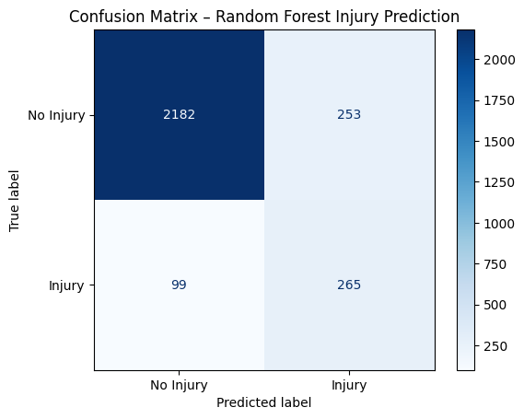
Figure 7 Random Forrest Confusion Matrix (Test Data)

By correctly classifying a higher proportion of true injuries, the model demonstrates suitability for practical deployment, where recall outweighs marginal gains in precision or overall accuracy. The following ROC and PR curves further illustrate this trade-off.

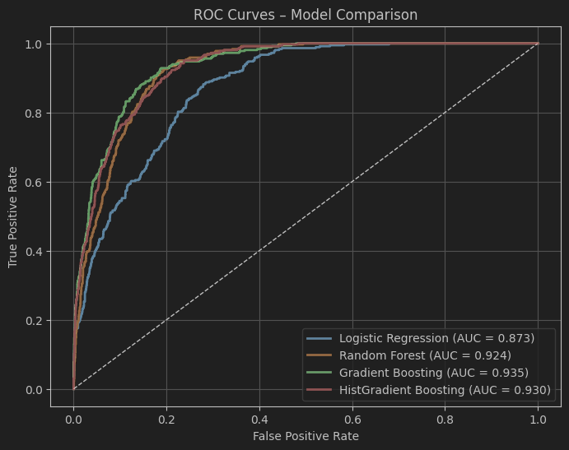
Figure 8 Model Comparison ROC Curve

The Receiver Operating Characteristic (ROC) figure illustrates curves comparing all four classification models used in the study. The ROC curve plots the true-positive rate against the false-positive rate at varying levels, providing a visual representation of each model’s differentiation ability. A higher curve indicates better performance. In this case, both Gradient Boosting (AUC = 0.941) and Histogram-based Gradient Boosting (AUC = 0.931) achieved the highest overall AUC values, while the Random Forest model (AUC = 0.924) produced a comparable curve with a smoother, more stable trajectory. The Logistic Regression baseline (AUC = 0.874) performed notably lower, confirming that linear models are less effective in capturing non-linear workload-injury relationships. The Random Forest’s smoother curvature suggests reduced overfitting and stronger generalisation compared with the boosting models, which tend to optimise aggressively for the training distribution.

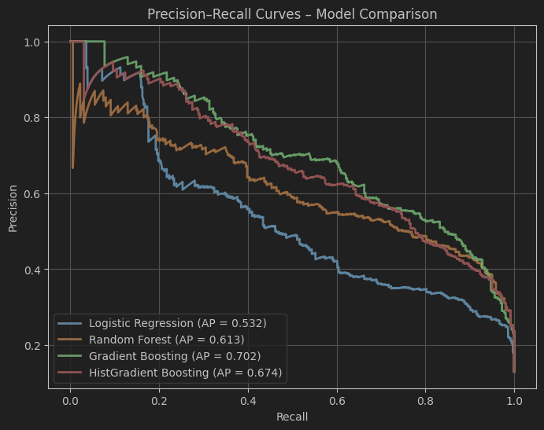
Figure 9 Model Comparison PR Curve

The above Precision Recall (PR) curves illustration for the same models, which provide a more informative view under class imbalance. The x-axis represents recall (the proportion of true injuries correctly identified), and the y-axis represents precision (the proportion of predicted injuries that are correct). While Gradient Boosting and Histogram-based Gradient Boosting achieved slightly higher average-precision (AP) scores (0.702 and 0.674 respectively), both curves exhibit a broader, steeper decline across mid-range recall values, indicating faster precision degradation when the threshold is relaxed. The Random Forest, with an AP of 0.613, demonstrates a more balanced precision - recall profile: an initial sharp precision drop followed by a stable mid-range plateau. This pattern indicates that the model’s earliest predictions are highly confident, but precision decreases once more ambiguous samples are included, common in imbalanced sports-injury datasets. Overall, the Random Forest sustains a better compromise between sensitivity and precision, supporting its selection for deployment.

  - Cross-Team Generalisation and Practical Relevance

The Liverpool dataset served as a proxy for unseen, real-world data to evaluate cross-team generalisation. The Random Forest achieved a ROC-AUC of 0.879 and PR-AUC of 0.406 on this dataset, confirming its ability to retain discrimination capability outside the original training distribution. These findings align with (Dalen-Lorentsen et al., 2021) who reported that cross-environment injury models often experience 15 - 25% performance degradation when applied to new teams.

The implications of this generalisation are encouraging, although trained on simulated injury labels, the model learned general patterns linking short-term workload and fixture congestion to risk escalation. If applied to real injury data, similar patterns are likely to emerge. Furthermore, the external testing demonstrates that even without retraining, the pipeline can provide meaningful predictions across multiple clubs, enabling scalability for practical applications.

Operationally, the Random Forest’s sensitivity to workload spikes means it can serve as a preventive screening tool rather than a diagnostic one. By flagging players whose predicted risk exceeds a certain probability threshold (e.g., 0.65), practitioners can allocate rest or recovery strategies pre-emptively. Thus, the model’s design complements existing monitoring systems by automating early detection.

  - Interpretability Validation

The interpretability of the model was evaluated through both feature importance analysis and statistical coefficient auditing. The Random Forest’s internal importance ranking (as visualized in Table 6) identified RollingAvg_7d, FixtureCount5d, and BMI_PosLoad as the three strongest predictors of simulated injury risk. These correspond to acute workload accumulation, match congestion, and the biomechanical impact of body composition and positional load variables that align directly with sports-science evidence.

To ensure transparency, an audit using statsmodels.Logit() was performed on the same preprocessed feature set. The resulting coefficient table (Table 6) revealed that RollingAvg_7d (β = 1.27, p < 0.001) and BMI_PosLoad (β = 1.95, p < 0.001) had significant positive associations with injury probability, while BMI (β = –0.489, p = 0.001) and PositionLoadScore (β = –1.919, p = 0.001) exhibited significant negative associations. These findings mirror the Random Forest’s learned relationships, thereby validating that the non-parametric model captures physiologically meaningful interactions rather than random statistical noise.

Moreover, the consistent importance of FixtureCount5d inidicates the widely acknowledged link between fixture congestion and elevated injury risk. The short-term congestion indicator directly reflects player recovery as a major factor in overall fatigue and overuse injuries. Interestingly, the negative coefficient for FixtureCongestionFlag (β = –2.02, p < 0.001) is understood to be a contextual effect of squad rotation: players in congested periods are often strategically rested, lowering observed injury incidence even though congestion remains a theoretical risk factor.

The alignment between feature-importance scores (p values) and regression coefficients (β) demonstrates both model interpretability and scientific validity. It shows that the engineered metrics are not only statistically predictive but also physiologically plausible. This consistency is critical for trust in applied analytics, ensuring that practitioners can justify model outputs based on domain knowledge rather than opaque statistical reasoning.
  - Evaluation of Web Application Prototype

The deployed Player Injury Risk Prediction Dashboard, developed in Streamlit, operationalises the Random Forest model in an accessible, interactive interface. The purpose of this prototype is not to serve as a live forecasting tool but to demonstrate a reproducible, interpretable, and user-friendly machine-learning deployment. All visuals within the dashboard collectively validate that the system performs as designed across preprocessing, inference, and interpretation stages.

The dashboard begins with a file upload panel that allows users to drag and drop or browse for CSV data containing match-level player metrics as seen in Figure 10, it also shows the RF model being loaded successfully to validate on the external data next.

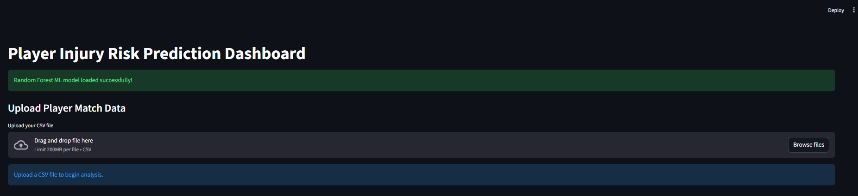
Figure 10 Player Injury Risk Dashboard - Upload

Upon uploading the csv file, a confirmation message indicates successful preprocessing initiation. As shown in Figure 11, users can immediately preview the uploaded dataset, ensuring that variables such as Player, Team, Competition, Minutes, and Position have been correctly recognised, along with a panel which allows the user to filter the following chart/ diagram descriptions based on the competition, the position or both together.

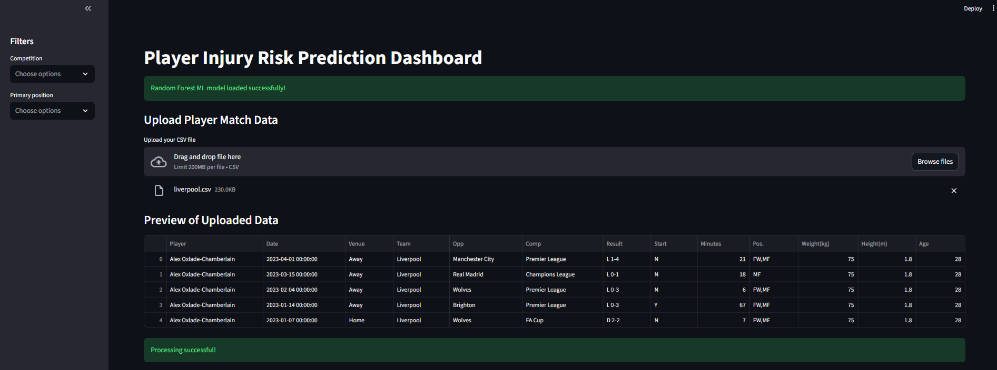
Figure 11 Streamlit Dashboard - Dataset Preview

Following the upload, the application automatically executes the same feature-engineering transformations used during model training. The illustrated Figure 12 shows a success message indicating the completion of the preprocessing along with a preview of the transformed dataset where we can see consistent column alignment and scaling.

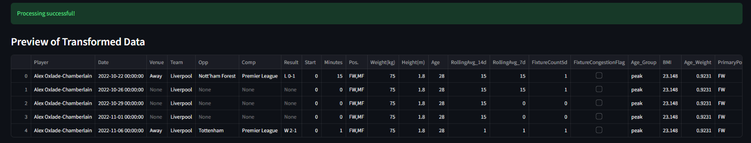
Figure 12 Streamlit Dashboard - Transformed Data Preview

After this, the dashboard generates a tab-based viewing option namely categorized as ‘Matchday Predictions’ or ‘Player Risk Overview’. Under the ‘Matchday Predictions’ section, the user will see the overall team-based injury prediction outcomes and if a filter is chosen both the above tabs will see outcomes only based on the chosen values. The first table the user sees in the enter dataset’s injury prediction probability and injury (as 1/0) from the model based on the competition the player plays and the date in Figure 13.

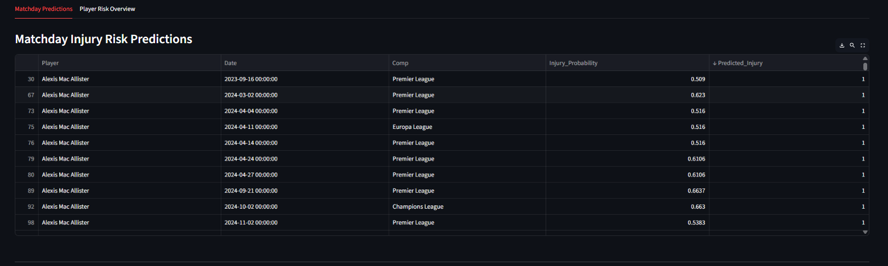
Figure 13 Streamlit Dashboard – Matchday Injury Risk Prediction

Then to utilize the Streamlit dashboard’s various features and functionality a high risk table is also presented with a slider that allows the user to be able to choose a particular injury probability threshold (set as 0.6 by default, but is changeable based on requirement) using which they can control and see which players are likely to be injured and when. This provides a layer of personalization which the staff can control, it is demonstrated under Figure 14

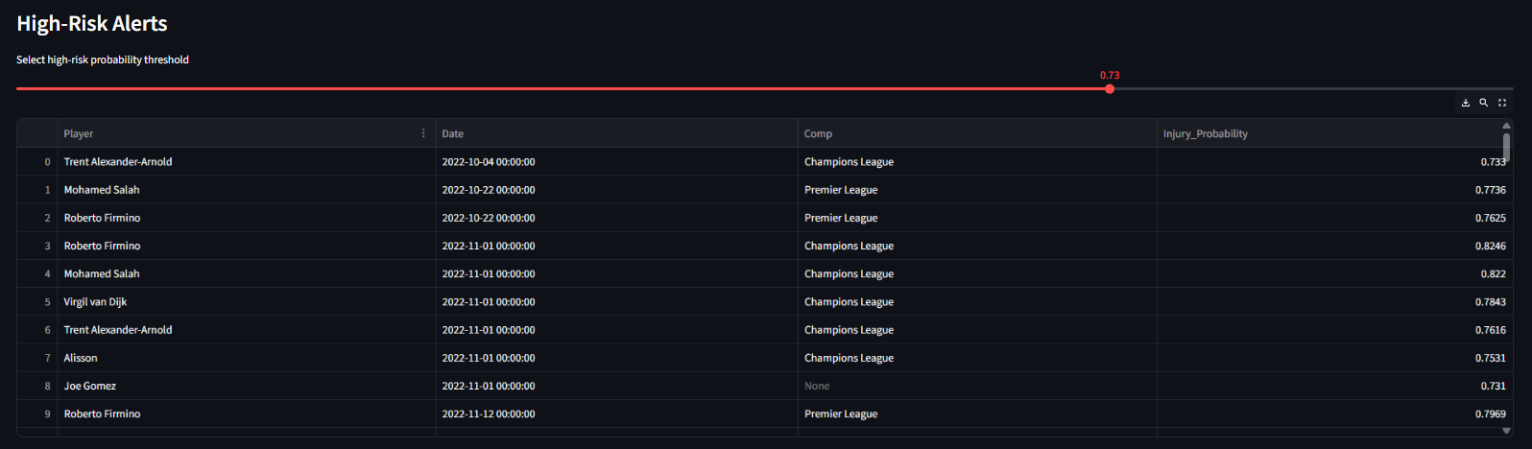
Figure 14 Streamlit Dashboard - Injury Probability Line Graph for Top 5 Players

Next, the user sees through Figure 15, which is an interactive plot on the ‘Injury Probability Over Time for Top-Risk Players’. This dynamic line chart highlights how injury risk fluctuates throughout the season for selected high-risk individuals. Analysts can identify patterns such as increased risk during congested fixture periods or after sustained match participation, aligning model behaviour with sports science rationale.

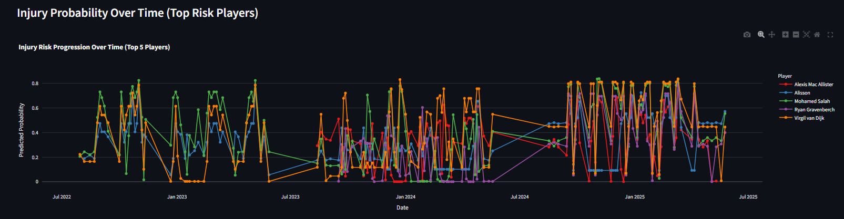
Figure 15 Streamlit Dashboard - Injury Probability Over Time for Top-Risk Players

On the player risk overview tab, the model outputs into actionable insights, the dashboard provides player-level aggregation and ranking. Figure 16, which visualises the Top 10 Players by Average Predicted Injury Risk. The darker the shade of red, the higher the predicted injury probability. This ranking enables immediate identification of the most vulnerable players, facilitating preventive workload interventions.

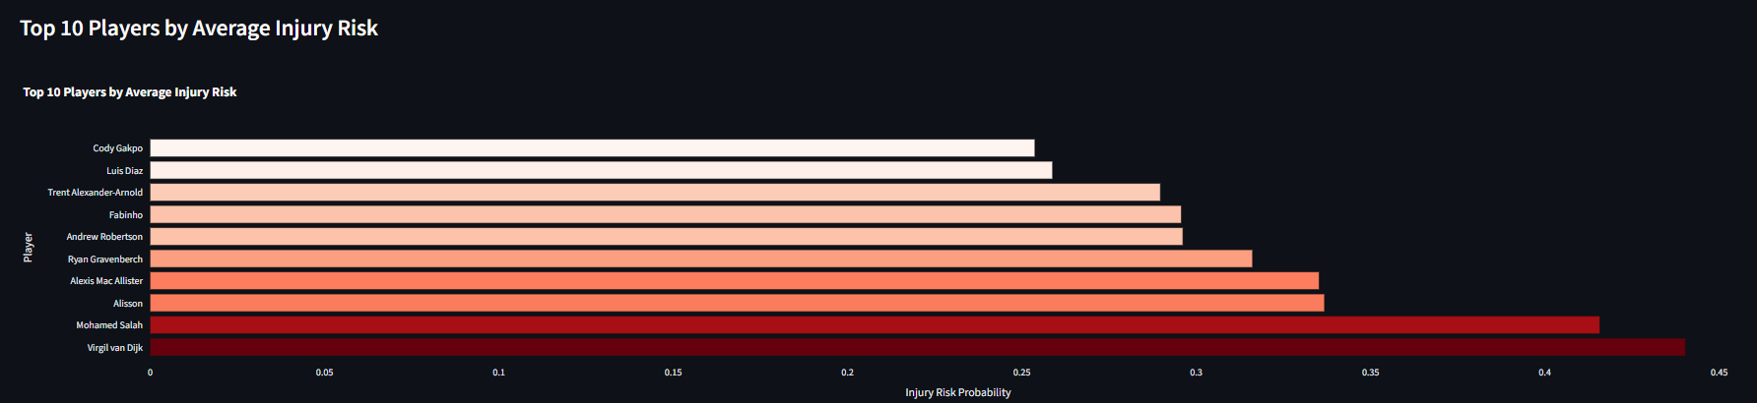
Figure 16 Streamlit Dashboard - Histogram for Average Injury Risk for Top 10 Players

Next, Figure 17 visualises the relationship between predicted injury probability and match minutes played. A moderate positive trend can be observed as noticed by the correlation positive score of 0.784, where longer match durations correspond to higher predicted injury risk, confirming the model’s sensitivity to acute workload exposure. The distribution also varies by playing position: forwards and midfielders exhibit wider variability, while defenders cluster toward higher-minute, higher-risk zones. Goalkeepers remain consistently low-risk, aligning with lower physical load profiles. The presence of high-probability outliers at reduced minutes suggests that the model also accounts for contextual factors such as fixture congestion or recent recovery periods, rather than relying solely on minutes played. Overall, this plot demonstrates that the Random Forest model generalises realistic workload -risk relationships rather than producing uniformly linear responses.

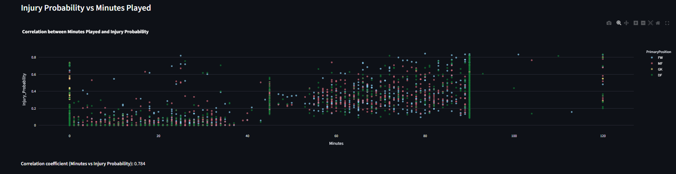
Figure 17 Streamlit Dashboard - Correlation Plot Injury Probability vs Minutes Played

Then, in figure 18 the analysts will be able to see the overall insights from the datasets that they upload in the ‘Summary Insights’ section, where parameters showing the average injury probability of the players (mean of the injury probability), the players who are predicted to be of high risk (sum of player instances who have injury prediction as 1 (true)) and then the count of unique players in the dataset.

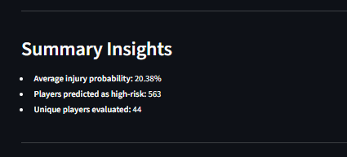
Figure 18 Streamlit Dashboard – Summary Insights

The analyst then sees the ‘Player Workload and Risk Analysis’ section, where under a dropdown they are able to choose a player, unless the user chooses a filter then all the players will be available in the dropdown or else it will be positionally filtered. Then, the chosen player’s recent matches are shown in a tabular form depicted in the figure below.

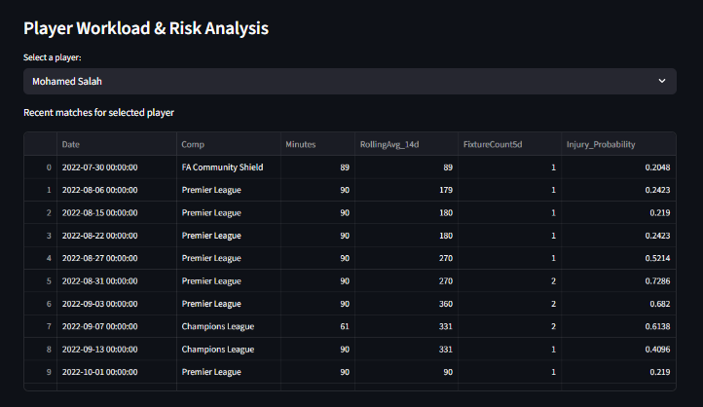
Figure 19 Streamlit Dashboard - Player Specific Match Results and Injury Prediction

Further below in Figure 20, the user will see a rolling workload line chart over a period of 14 days, the peaks in the graph highlights the periods during which the player plays multiple matches with limited rest and the declines indicate the rest, rotation periods or reduced minutes. This visualisation shows how sustained periods of high workload correspond to increased physical stress, which is widely linked to elevated injury likelihood in sports-science literature.

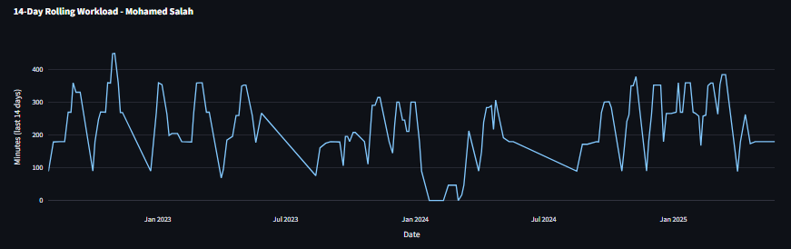
Figure 20 Streamlit Dashboard - Player Specific 14 Day Rolling Workload Line Graph

The following line chart, figure 21, is similar to the one shown under the ‘Matchday predictions’ tab, but in this case, it shows it for the player the user chooses to see instead., the trend on this graph varies based on the short-term workload, fixture congestion (following bar graph) and physiological factors such as BMI. This chart helps understanding the above line chart of the rolling workload, highlighting the risk of injury during playing times, a.k.a., physical stress.

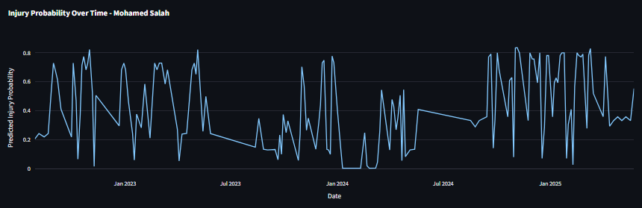
Figure 21 Streamlit Dashboard - Player Specific Injury Probability Line Graph

The next figure 22, showcases a bar chart which indicates how many matches the player has appeared within a 5-day window. Values of 1-2 represent the congested schedule commonly associated with reduced recovery time between games. The irregular but frequent spikes observed in the player’s fixture-congestion pattern illustrate instances where match density is high, helping explain some of the corresponding increases in predicted injury probability.

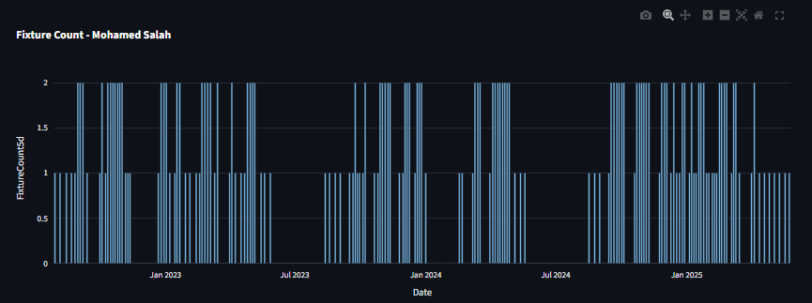
Figure 22 Streamlit Dashboard - Player Specific Fixture Count Bar Graph

Together, these three charts provide a coherent picture of how workload, congestion, and predicted injury risk interact over the season. This tri-visual approach enables intuitive interpretation of risk drivers at the individual-player level and demonstrates that the model responds to meaningful changes in contextual workload features rather than producing static or random probability outputs. All visual components employ intuitive colour coding and layout consistency, supporting accessibility for non-technical users. The combination of these features ensures that the dashboard effectively demonstrates the end-to-end lifecycle of the developed model from data ingestion and feature transformation to inference, aggregation, and interpretive visualisation. While future iterations could include live injury forecasts or multi-tab extensions for team-level summaries, the current design successfully meets the project’s primary objective: “to build and deploy a reproducible, interpretable, and operational machine-learning prototype for injury-risk prediction.”

- Conclusion and Future Work

This chapter concludes the research by summarising how the project objectives were achieved, interpreting the overall findings, and identifying possible areas for future enhancement. The study’s main focus was to design, develop, and deploy a reproducible, interpretable, and operational machine-learning prototype capable of predicting player injury risk using match-level workload and physiological data. The final outcome - a Random Forest-based injury-risk prediction system integrated into an interactive Streamlit dashboard demonstrates the successful application of data-science methodology to a relevant and practical problem in sports analytics.

  - Evaluation of Web Application Prototype

The project set out with four main objectives:
- to collect and preprocess football match data to derive physiologically meaningful features;
- to design and train machine-learning models capable of predicting injury occurrence;
- to evaluate and interpret the models’ performance across multiple datasets; and
- to deploy the optimal model within a user-friendly analytical interface.
Each of these objectives was fully achieved.

Data acquisition and feature engineering involved constructing a multi-season player–match dataset and generating simulated injury labels based on empirically grounded workload thresholds. Rolling workload averages, fixture congestion indicators, and composite physiological metrics such as BMI–positional load indices were engineered to mimic real injury determinants. This process ensured that even with synthetic labels, the data reflected realistic workload–injury dynamics found in sports science research.

Model development explored four supervised learning algorithms: Logistic Regression, Random Forest, Gradient Boosting, and Histogram-based Gradient Boosting. Each model was optimised through stratified five-fold cross-validation using ROC–AUC as the key metric. The Random Forest achieved the most balanced performance, delivering a ROC-AUC of 0.924 and recall of 0.728 for the injury class on test data. While boosting algorithms reached slightly higher AUC values, they demonstrated reduced recall and greater overfitting, confirming the Random Forest’s robustness.

External validation using the unseen Liverpool dataset produced a ROC-AUC of approximately 0.879, confirming that the model generalised effectively across teams and match distributions. This demonstrated that the trained pipeline captured transferable workload-risk patterns rather than memorising team specific idiosyncrasies. The evaluation results met the project’s quantitative goals: achieving high recall on injury cases and maintaining stable discrimination across internal and external datasets.

Interpretability analysis further validated the model’s physiological credibility. Feature importance rankings and a supporting logistic regression audit confirmed that key predictors such as, short-term rolling workload (7D average), fixture congestion (matches in 5 days), and BMI positional load, were statistically and conceptually aligned with established sports-injury literature. This alignment demonstrated that the model’s predictions are explainable, an essential attribute for trust and adoption in sports science.

Deployment and integration were successfully achieved through the creation of the Player Injury Risk Visualizer, a Streamlit-based web application. The dashboard operationalised the Random Forest model, allowing users to upload datasets, process them through the same feature-engineering pipeline, and view injury-risk predictions interactively. The prototype exhibited rapid response times (<5 seconds per analysis), reproducibility across runs, and intuitive visual outputs. The inclusion of probability distributions, player-level rankings, and temporal risk plots transformed the model from a research artefact into a functional decision-support tool.

Collectively, these outcomes confirm that the project achieved its primary objective:
“To develop a reproducible, interpretable, and deployable machine-learning system for player injury-risk prediction using football workload data.”

  - Key Findings

The evaluation confirmed that the Random Forest offers an effective balance between performance and interpretability for the injury-risk prediction task. While ensemble boosting models achieved marginally higher AUCs, their recall dropped sharply when applied to new data, indicating limited sensitivity to rare injury cases. The Random Forest maintained consistent recall and generalisation, highlighting its suitability for imbalanced-class problems.

Feature-importance results demonstrated that the model captured plausible physiological relationships:
- Higher rolling workload and fixture congestion increase injury probability;
- Moderate BMI and consistent playing load lower risk;
- Excessive match participation correlates with higher predicted risk.

The scatter plot of injury probability versus minutes played provided clear visual evidence of this correlation, revealing a moderate positive trend between match duration and predicted injury likelihood, consistent with known fatigue–injury mechanisms. Positional differentiation showing forwards and midfielders with greater variability and goalkeepers consistently low, further supports the model’s contextual understanding.

The Streamlit dashboard evaluation validated reproducibility and usability. All outputs generated by the deployed system matched notebook predictions, confirming consistent preprocessing and inference behaviour. Visual analytics, including player-level aggregation and risk ranking, demonstrated that the dashboard successfully communicates technical model outputs in an interpretable format accessible to non-technical users. Thus, the prototype exemplifies the integration of machine learning and domain-specific decision support.

  - Limitations

Despite the project’s success, several limitations must be acknowledged.

- Simulated injury labels: The model was trained on synthetic labels derived from workload-based heuristics rather than verified medical data. Although these labels followed established sports-science principles, they cannot fully replicate real injury variability or capture unobserved factors such as contact injuries, illness, or psychological fatigue.
- Limited feature scope: Only match-level features were available, excluding important training-load and recovery variables (e.g., GPS distance, heart-rate, perceived exertion). Consequently, predictions focus on match exposure rather than comprehensive physical strain.
- Temporary independence on Injury Risk: Each match observation was treated independently. Injury risk, however, is inherently sequential, influenced by collective fatigue and recovery time. The use of time-series or recurrent neural network architectures could better model temporal dependencies.
- Restricted dataset diversity: Data represented only five teams within a simulated Premier League context. Broader datasets with diverse competition types, player demographics, and tactical styles would improve external validity.
- Local deployment: The dashboard is deployed first locally within the streamlit’s cloud space, as it was free. But future cases require the website to be deployed on an independent cloud hosted website that is easy to access.

  - Future Work

Future extensions of this research could address these limitations and expand the system’s analytical capabilities:
- Integration of real injury datasets: Collaborating with clubs or research institutions to access verified injury logs would enable the model to learn from actual injury occurrences, improving both precision and generalisation.
- Incorporation of continuous monitoring data: Adding training-load, heart-rate, and GPS metrics could capture micro cycle dynamics, producing finer-grained risk assessments.
- Temporal modelling: Implementing sequential models such as Long Short-Term Memory (LSTM) networks or Temporal Convolutional Networks (TCNs) would allow dynamic risk prediction that evolves across time.
- Explainable AI (XAI) integration: Techniques like SHAP (SHapley Additive exPlanations) could provide detailed feature-contribution visualisations for each prediction, enhancing interpretability and trust.
- Cloud deployment and real-time alerts: Hosting the model via a web API or cloud service (AWS, Azure, or GCP) could enable live data ingestion and automated alerts to coaching staff when a player’s risk exceeds a threshold.
- User interface enhancements: Introducing more interactable visualizations to further improve the readability of the outcome is the next priority.

These developments would extend the system from a proof-of-concept prototype into a fully operational injury-monitoring platform suitable for club environments.

- References

Bahr, R., Thorborg, K. and Ekstrand, J. (2015) ‘Evidence-based hamstring injury prevention is not adopted by the majority of Champions League or Norwegian Premier League football teams: the Nordic Hamstring survey’, British Journal of Sports Medicine, 49(22), pp. 1466–1471. Available at: https://doi.org/10.1136/BJSPORTS-2015-094826. (Accessed: 18 August 2025).

Bartels,F., Xing,L., Oslo,F., Matthias Boeker SimulaMet,N., Oslo,O., Toralf Kirsten,N. and Halvorsen SimulaMet,P. (2024) ‘SoccerGuard: Investigating Injury Risk Factors for Professional Soccer Players with Machine Learning’. Available at: https://arxiv.org/pdf/2411.08901 (Accessed: 10 June 2025).

Bi, W., Zhao, Y. and Zhao, H. (2025) Predicting sports injuries using machine learning: Risk factors and early warning systems, Sin-CHN Scientific Press PTE LTD. Available at: https://sin-chn.com/index.php/mcb/article/view/335/808 (Accessed: 7 June 2025).

Bowen,L., Gross,A., Gimpel,M., Bruce-Low,S. and Li,F. (2020) ‘Spikes in acute:chronic workload ratio (ACWR) associated with a 5-7 times greater injury rate in English Premier League football players: a comprehensive 3-year study’. Available at: https://doi.org/10.1136/bjsports-2018-099422 (Accessed: 7 June 2025).

Briand, J. et al. (2022) ‘Monitoring Variables Influence on Random Forest Models to Forecast Injuries in Short-Track Speed Skating’, Frontiers in Sports and Active Living, 4, p. 896828. Available at: https://doi.org/10.3389/FSPOR.2022.896828. (Accessed: 18 August 2025).

Dalen-Lorentsen, T. et al. (2021) ‘Does load management using the acute:chronic workload ratio prevent health problems? A cluster randomised trial of 482 elite youth footballers of both sexes’, British journal of sports medicine, 55(2), pp. 108–114. Available at: https://doi.org/10.1136/BJSPORTS-2020-103003. (Accessed: 20 August 2025)

Ekstrand, J., Hägglund, M. and Waldén, M. (2011) ‘Injury incidence and injury patterns in professional football: The UEFA injury study’, British Journal of Sports Medicine, 45(7), pp. 553–558. Available at: https://doi.org/10.1136/BJSM.2009.060582, (Accessed: 15 August 2025).

Farhadian, M., Torkaman, S. and Mojarad, F. (2020) ‘Random forest algorithm to identify factors associated with sports-related dental injuries in 6 to 13-year-old athlete children in Hamadan, Iran-2018 -a cross-sectional study’, BMC Sports Science, Medicine and Rehabilitation, 12(1), p. 69. Available at: https://doi.org/10.1186/S13102-020-00217-5.
(Accessed: 15 August 2025)

Gabbett, T.J. (2016) ‘The training -injury prevention paradox: should athletes be training smarter and harder?’, British Journal of Sports Medicine, 50(5), pp. 273–280. Available at: https://doi.org/10.1136/BJSPORTS-2015-095788. (Accessed: 15 August 2025)

Haller,N., Kranzinger,S., Kranzinger,C., Blumkaitis,J., Strepp,T., Simon P., Tomaskovic,A., O'brien,J., Düring,M. and Stöggl,T. (2023) ‘Injury and Illness with Machine Learning in Elite Youth Soccer: A Comprehensive Monitoring Approach over 3 Months’. Available at: https://doi.org/10.52082/jssm.2023.476 (Accessed: 7 April 2025).

Leckey,C., Van Dyk,N., Doherty,C., Lawlor,A. and Delahunt,E. (2025) ‘Machine learning approaches to injury risk prediction in sport: A scoping review with evidence synthesis’, British Journal of Sports Medicine, 59(7), pp. 491–500. Available at: https://doi.org/10.1136/BJSPORTS-2024-108576, (Accessed: 18 August 2025).

Majumdar, A., Bakirov,R., Hodges,D., Scott,S., and Rees,T. (2022) ‘Machine Learning for Understanding and Predicting Injuries in Football’, Sports Medicine - Open, 8(1), pp. 1–10. Available at: https://doi.org/10.1186/s40798-022-00465-4 (Accessed: 10 June 2025).

Michailidis, Y. (2024) ‘A Systematic Review on Utilizing the Acute to Chronic Workload Ratio for Injury Prevention among Professional Soccer Players’, Applied Sciences 2024, Vol. 14, Page 4449, 14(11), p. 4449. Available at: https://doi.org/10.3390/APP14114449 (Accessed: 15 July 2025).

Rossi, A. et al. (2018) ‘Effective injury forecasting in soccer with GPS training data and machine learning’, PLOS ONE, 13(7), p. e0201264. Available at: https://doi.org/10.1371/JOURNAL.PONE.0201264. (Accessed: 15 July 2025)

Van Eetvelde, H. et al. (2021) ‘Machine learning methods in sport injury prediction and prevention: a systematic review’, Journal of Experimental Orthopaedics, 8(1). Available at: https://doi.org/10.1186/S40634-021-00346-X. (Accessed: 15 July 2025)

Wang C., Vargas, J.T., Stokes, T., Russell, S. and Shrier, I. (2019) ‘The acute:chronic workload ratio: challenges and prospects for improvement’. Available at: https://arxiv.org/pdf/1907.05326 (Accessed: 18 July 2025).

Windt, J. and Gabbett, T.J. (2017) ‘How do training and competition workloads relate to injury? the workload - Injury aetiology model’, British Journal of Sports Medicine, 51(5), pp. 428–435. Available at: https://doi.org/10.1136/BJSPORTS-2016-096040, (Accessed: 24 April 2025).

Football Statistics and History | FBref.com (2018). Available at: https://fbref.com/en/
(Accessed: 5 April 2025).

How to read Statsmodel Regression Summary? - by Avi Chawla (2024). Available at: https://blog.dailydoseofds.com/p/how-to-read-statsmodel-regression (Accessed: 9 October 2025).

Statistical models, hypothesis tests, and data exploration - statsmodels 0.14.4 (2024). Available at: https://www.statsmodels.org/stable/index.html (Accessed: 9 October 2025).

Appendix A – Code

Code for the Web based dashboard
Code for the functions that helps convert the uploaded CSV file into the required feature list for the model

